**[Project : Visualize Data using Amazon QuickSight (Beginner)](https://github.com/techwithlucy/youtube/blob/main/5-mini-aws-projects.md" \l "project-2-visualize-data-using-amazon-quicksight-beginner)**

In this project, we will guide you through the process of creating visualizations from a large dataset using two powerful tools - Amazon S3 and Amazon Quicksight. Our dataset consists of 50,000 best-selling products on Amazon.com, providing a wealth of information for analysis.

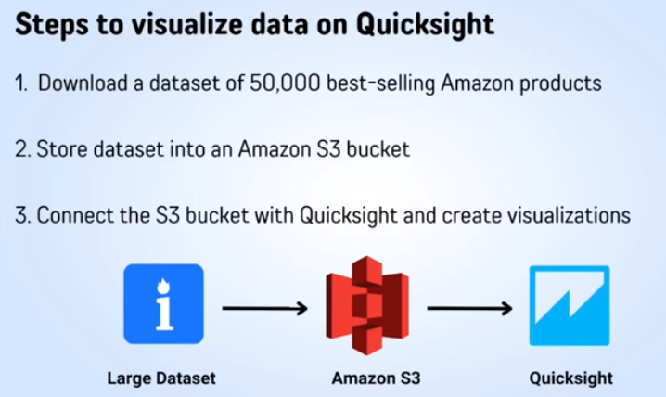

### [**Step #1: Download the Dataset**](https://github.com/techwithlucy/youtube/blob/main/5-mini-aws-projects.md#step-1-download-the-dataset)

* Navigate to [2-s3-quicksight](https://github.com/techwithlucy/youtube) to download the "Amazon Bestseller Dataset" CSV file and the "manifest.json" file.
* Click on "raw" and Control+S to save both files onto your computer.

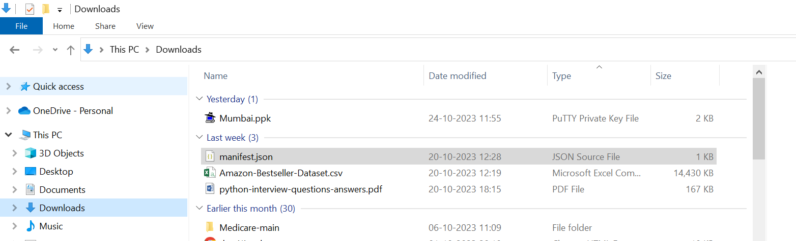

This dataset holds valuable insights into consumer trends and preferences on one of the world's largest e-commerce platforms.

### [**Step #2: Store the Dataset in Amazon S3**](https://github.com/techwithlucy/youtube/blob/main/5-mini-aws-projects.md#step-2-store-the-dataset-in-amazon-s3)

* Open the Amazon S3 console and click "Create Bucket."
* Name the bucket (“amazon-project") and keep the settings as default.

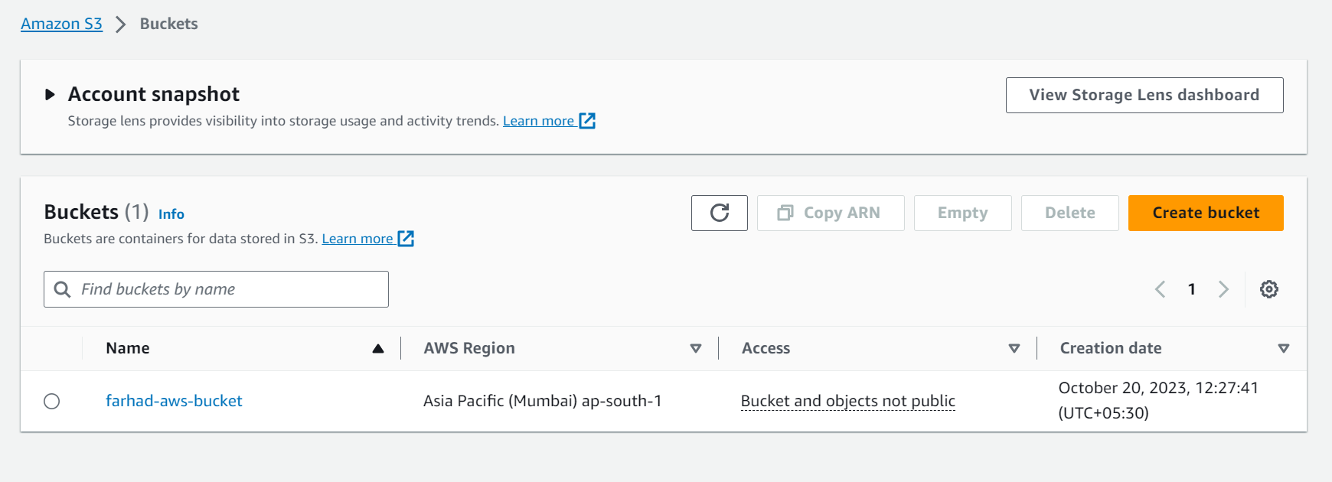

* Upload the CSV file and the "manifest.json" file into the bucket.
* Replace the URL in the "manifest.json" file with the S3 URL of your dataset.

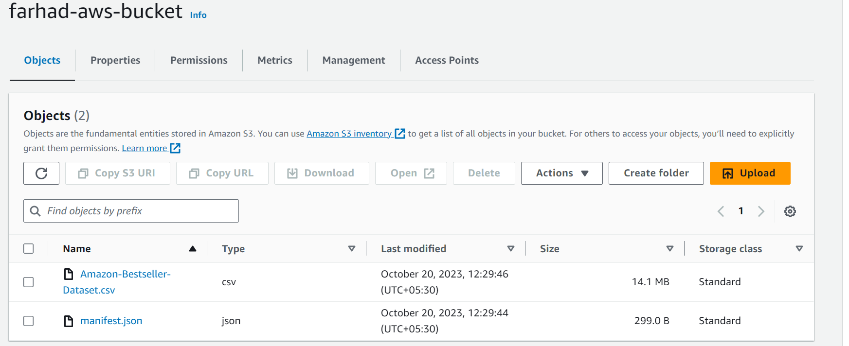

### [**Step #3: Connect S3 Bucket with Amazon Quicksight**](https://github.com/techwithlucy/youtube/blob/main/5-mini-aws-projects.md#step-3-connect-s3-bucket-with-amazon-quicksight)

* Open the AWS management console and navigate to Amazon Quicksight.
* Sign up for a free trial of the Enterprise edition if you don't have an account.

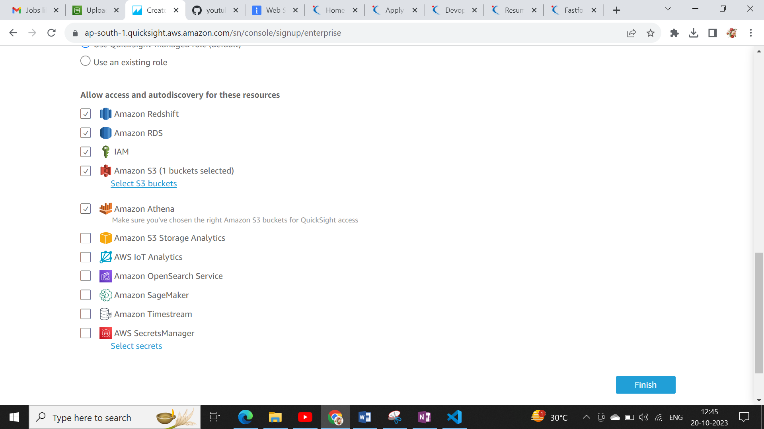

* Select Amazon S3 and tick the box for the S3 bucket you created.
* Enter the link to your "manifest.json" file and connect to Quicksight.
* Select "interactive sheet" to start creating visualizations.

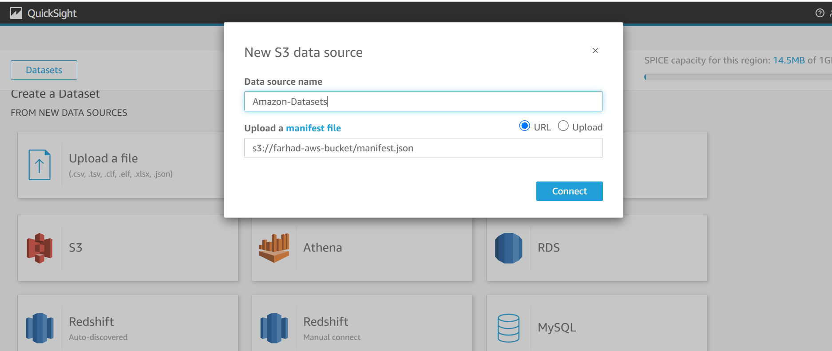

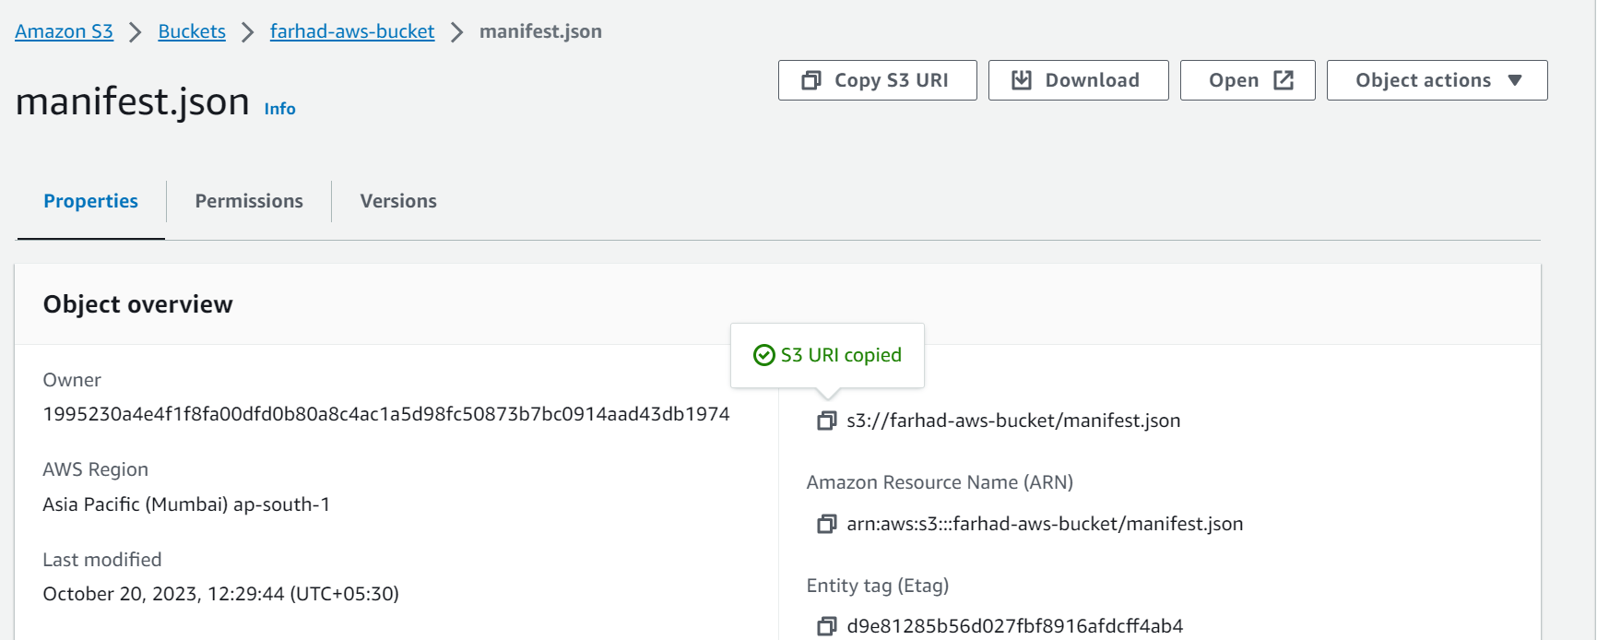

### [**Step #4: Create Visualizations**](https://github.com/techwithlucy/youtube/blob/main/5-mini-aws-projects.md#step-4-create-visualizations)

* Drag fields into the graph to create visualizations (e.g., Most popular brands).
* Sort, filter, and customize the graphs as desired.

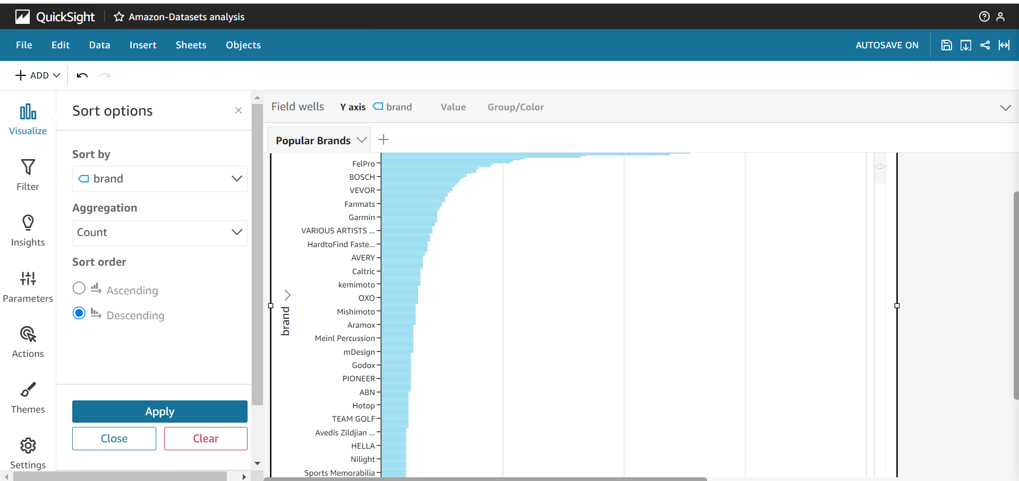

* Experiment with different types of graphs like bar charts, pie charts, line graphs, etc.

